## 4.3 PRODUCT PAGE:

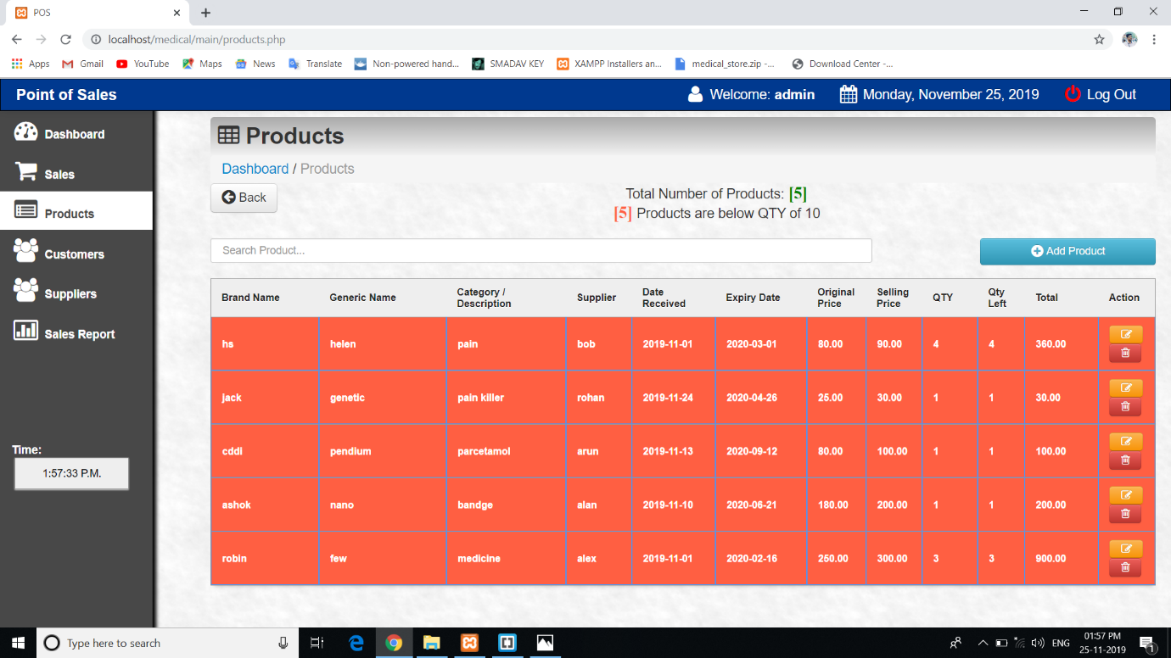

# **Fig 4.3: Product Page**

**4.4 CUSTOMER PAGE:**

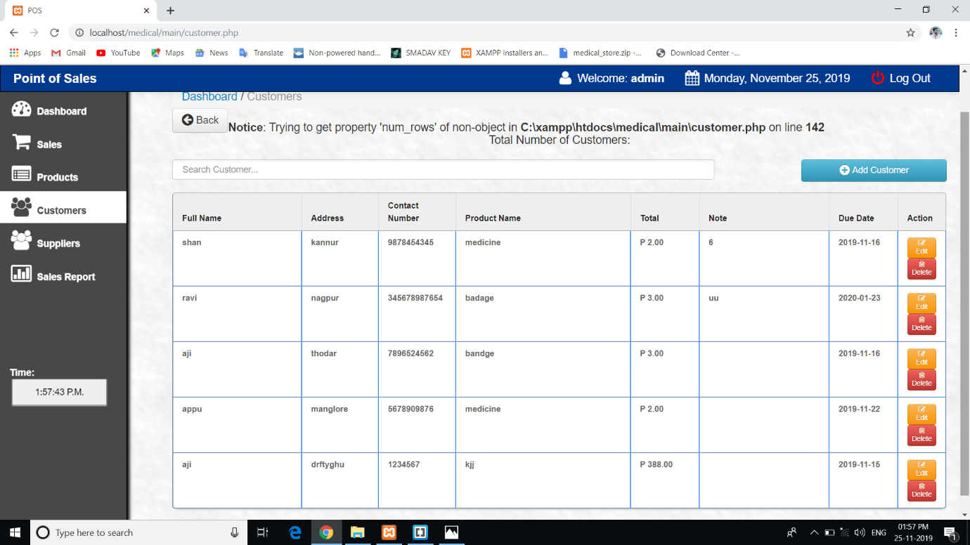

**Fig 4.4: Customer Page**